# Step 1 provision Kubernetes Cluster

* Click the **Catalog** button on the top
* Select **Service** from the catalog
* Search for **Kubernetes Service** and click on it

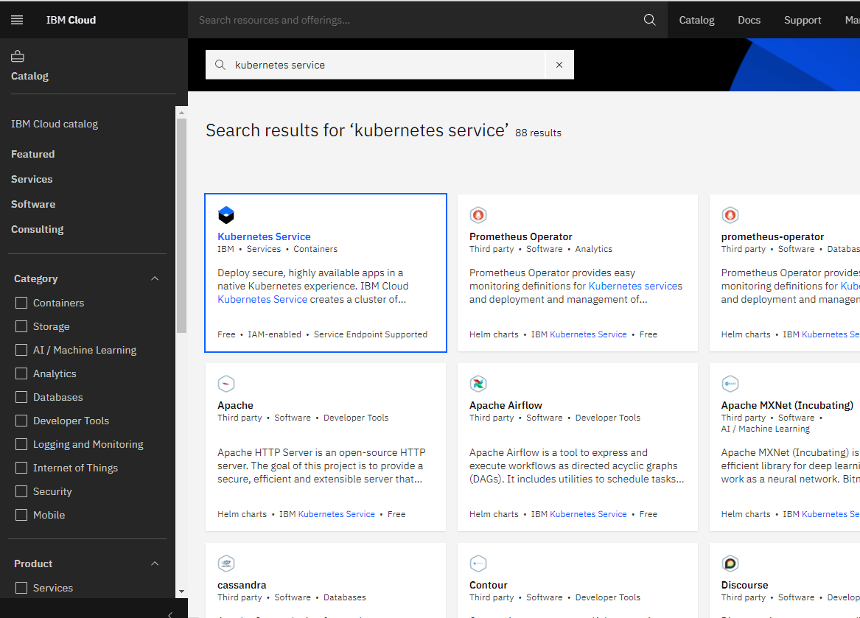

* You are now at the Kubernetes deployment page, you need to specify some details about the cluster
* Choose a plan **standard** or **free**, the free plan only has one worker node and no subnet, to provision a standard cluster, you will need to upgrade you account to Pay-As-You-Go
* To upgrade to a Pay-As-You-Go account, complete the following steps:
* In the console, go to Manage > Account.
* Select Account settings, and click Add credit card.
* Enter your payment information, click Next, and submit your information
* Choose **classic** or **VPC**, read the [docs](https://cloud.ibm.com/docs/containers?topic=containers-infrastructure_providers) and choose the most suitable type for yourself

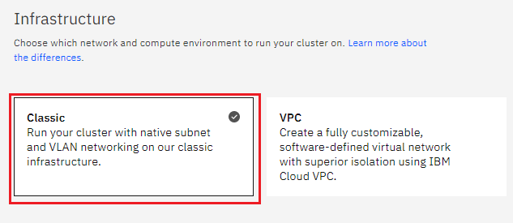

* Now choose your location settings, for more information please visit [Locations](https://cloud.ibm.com/docs/containers?topic=containers-regions-and-zones#zones)
* Choose **Geography** (continent)

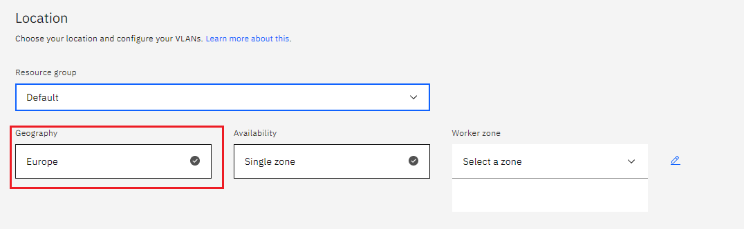

* Choose Single or Multizone, in single zone your data is only kept in on datacenter, on the other hand with Multizone it is distributed to multiple zones, thus safer in an unforseen zone failure

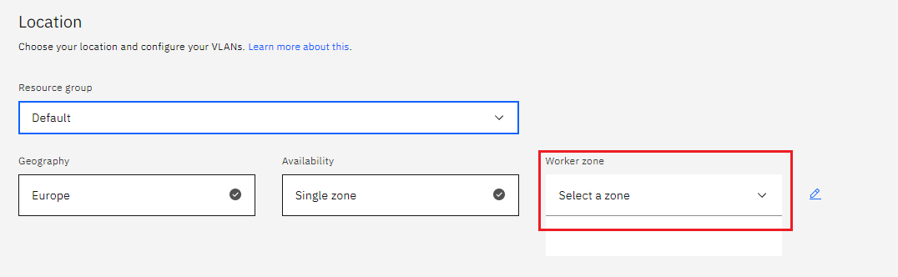

* If you wish to use Multizone please set up your account with [VRF](https://cloud.ibm.com/docs/dl?topic=dl-overview-of-virtual-routing-and-forwarding-vrf-on-ibm-cloud) or [enable Vlan spanning](https://cloud.ibm.com/docs/vlans?topic=vlans-vlan-spanning#vlan-spanning)
* If at your current location selection, there is no available Virtual LAN, a new Vlan will be created for you
* Choose a Worker node setup or use the preselected one, set Worker node amount per zone

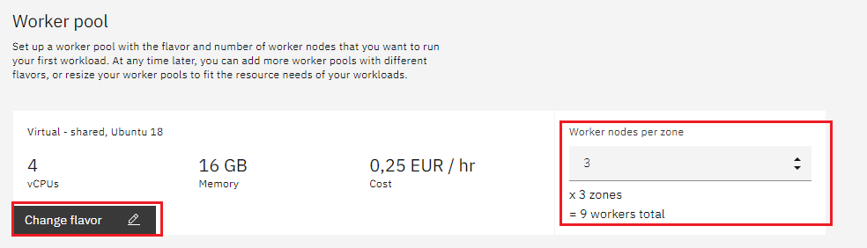

* Choose **Master Service Endpoint**, In VRF-enabled accounts, you can choose private-only to make your master accessible on the private network or via VPN tunnel. Choose public-only to make your master publicly accessible. When you have a VRF-enabled account, your cluster is set up by default to use both private and public endpoints. For more information visit [endpoints](https://cloud.ibm.com/docs/account?topic=account-service-endpoints-overview).

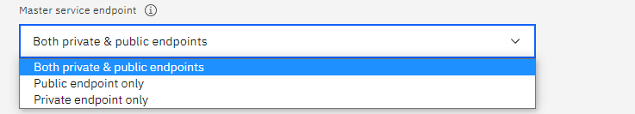

* Give cluster a name

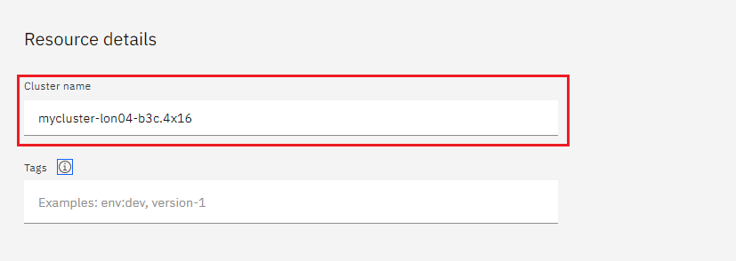

* Give desired **tags** to your cluster, for more information visit [tags](https://cloud.ibm.com/docs/account?topic=account-tag)

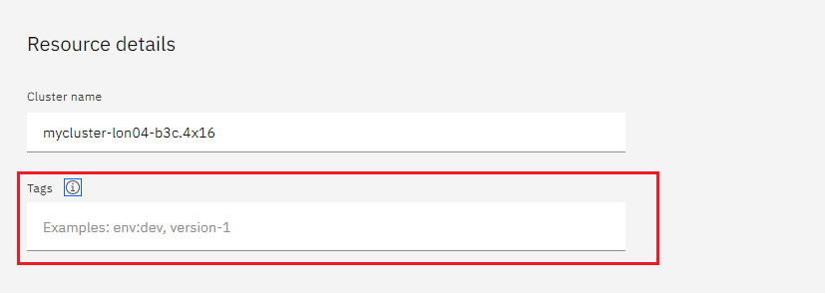

* Click **create**

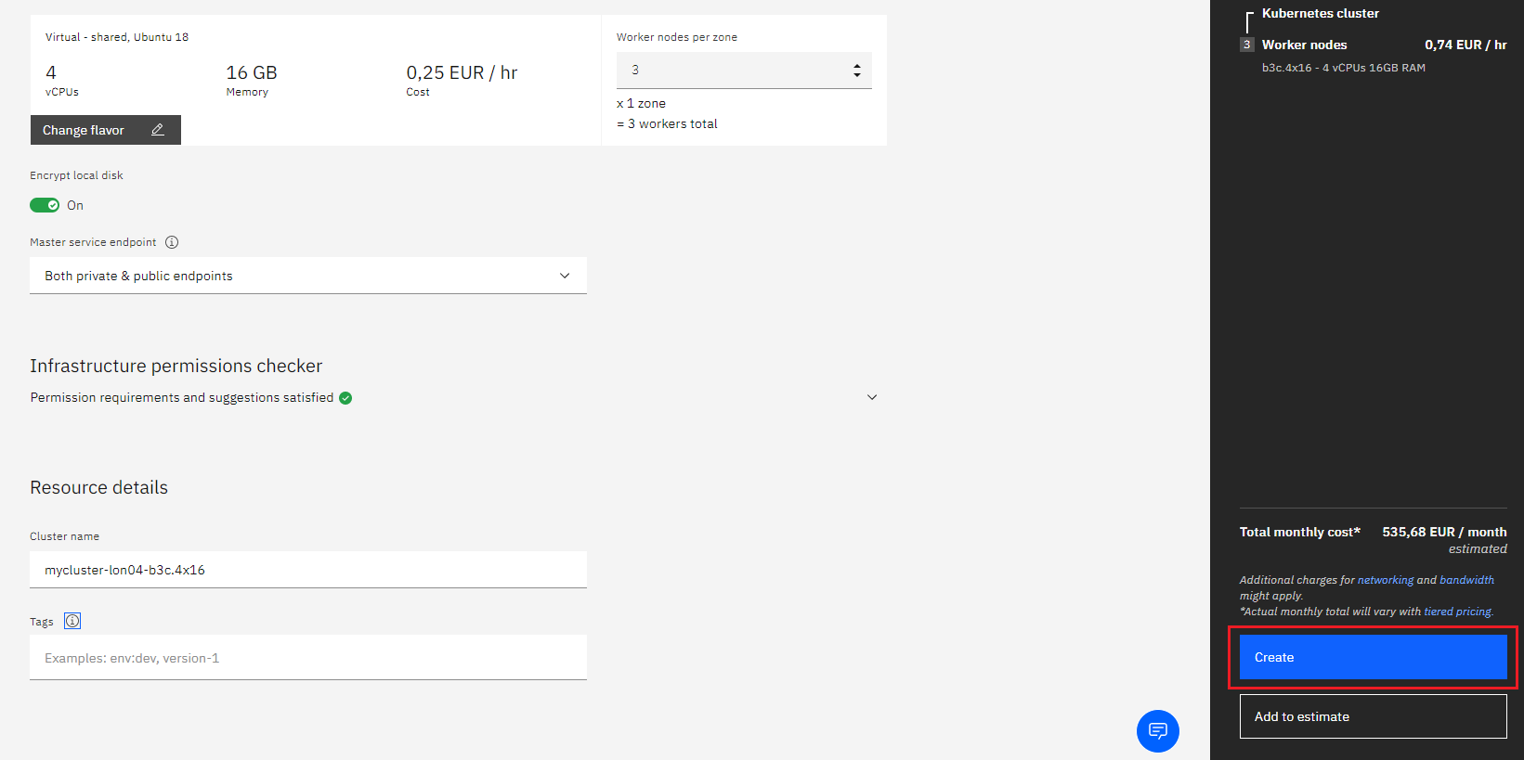

* Wait for you cluster to be provisioned



* Your cluster is ready for usage

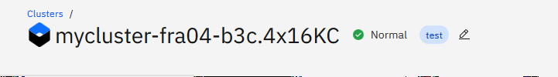

# Step 2 deploy IBM Cloud Block Storage plug-in

The Block Storage plug-in is a persistent, high-performance iSCSI storage that you can add to your apps by using Kubernetes Persistent Volumes (PVs).

* Click the **Catalog** button on the top
* Select **Software** from the catalog
* Search for **IBM Cloud Block Storage plug-in** and click on it

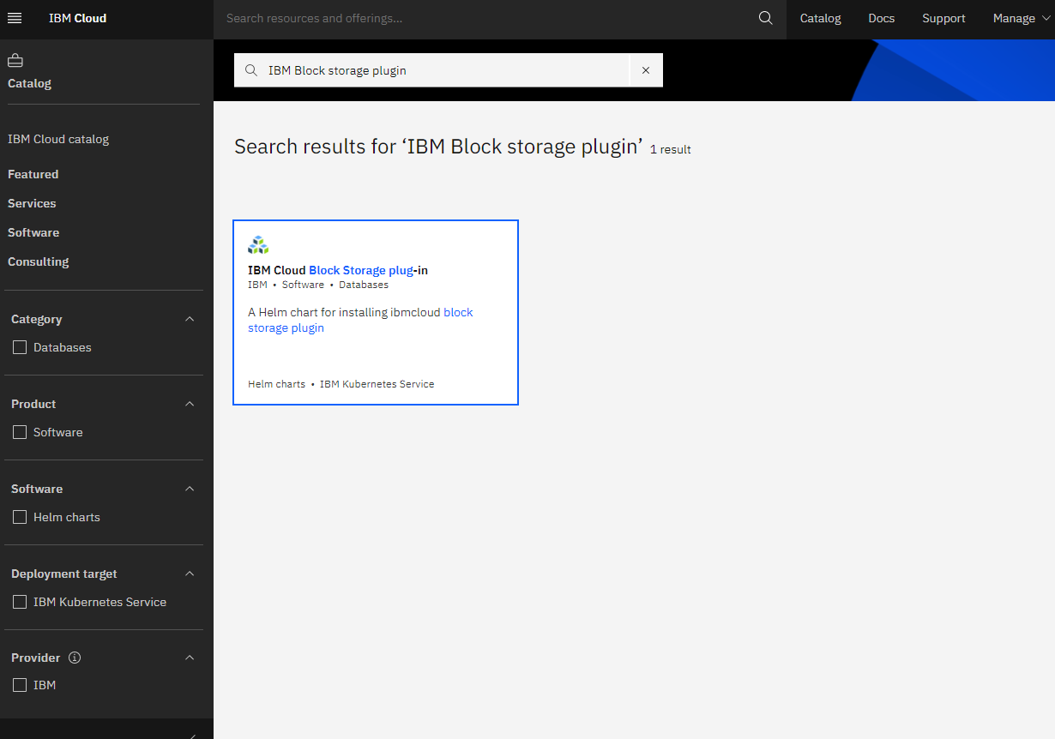

* On the application page Click in the dot next to the cluster, you wish to use
* Click on Enter or Select Namespace and choose the default Namespace or use a custom one (if you get error please wait 30 minutes for the cluster to finalize)

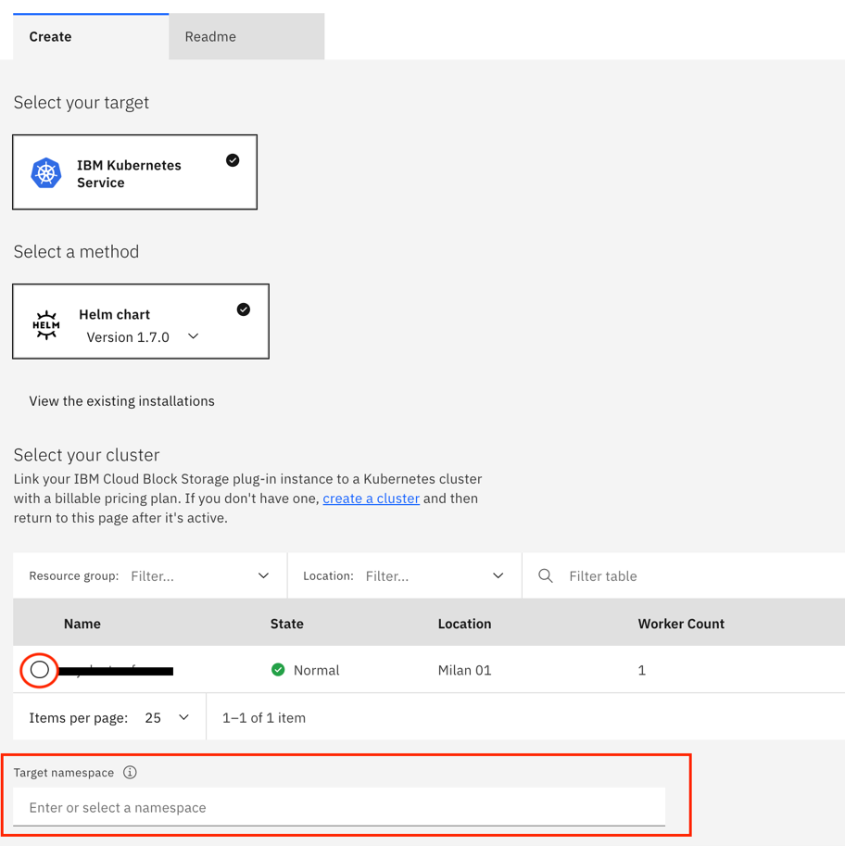

* Give a **name** to this workspace
* Click **install** and wait for the deployment

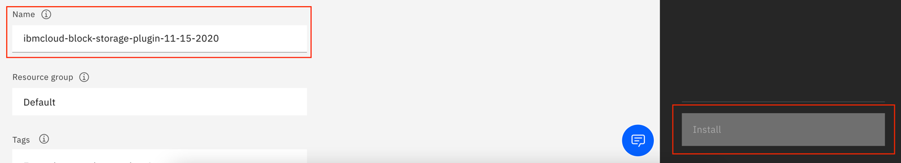

# Step 3 deploy OwnCloud

We will deploy OwnCloud on our cluster

* Click the **Catalog** button on the top
* Select **Software** from the catalog
* Search for **OwnCloud** and click on it

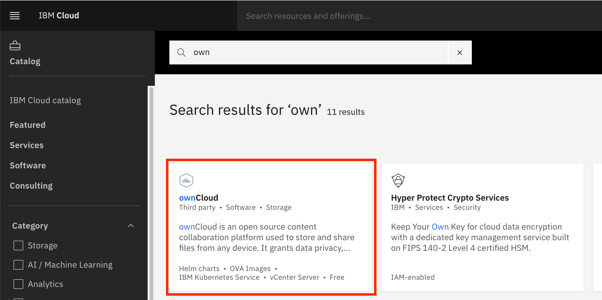

* Please select IBM Kubernetes Service

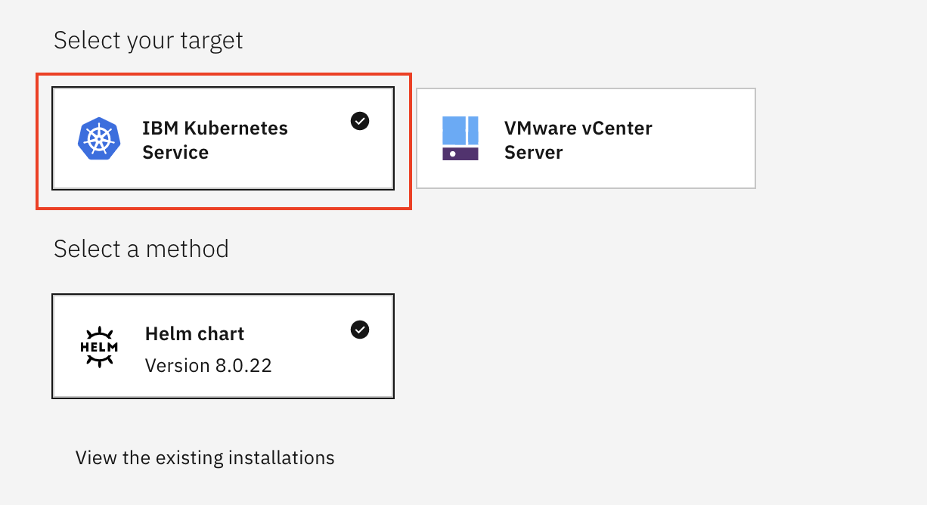

* On the application page Click in the dot next to the cluster, you wish to use

* Click on **Enter or Select Namespace** and choose the default Namespace or use a custom one

* Give a unique **name** to workspace, which you can easily recognize

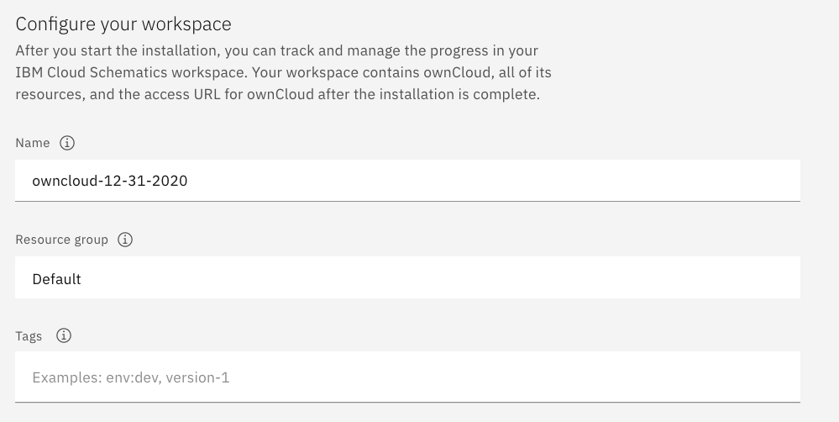

* Select which resource group you want to use, it's for access control and billing purposes. For more information please visit [resource groups](https://cloud.ibm.com/docs/account?topic=account-account_setup#bp_resourcegroups)

* Give **tags** to your OwnCloud, for more information visit [tags](https://cloud.ibm.com/docs/account?topic=account-tag)

* Click on **Parameters with default values**, You can set deployment values or use the default ones

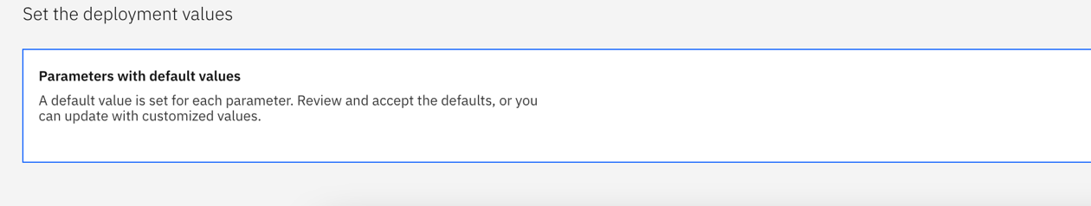

* Enter the required Parameters as shown.





Enter the hostname of your server.

* After finishing everything, **tick** the box next to the agreements and click **install**

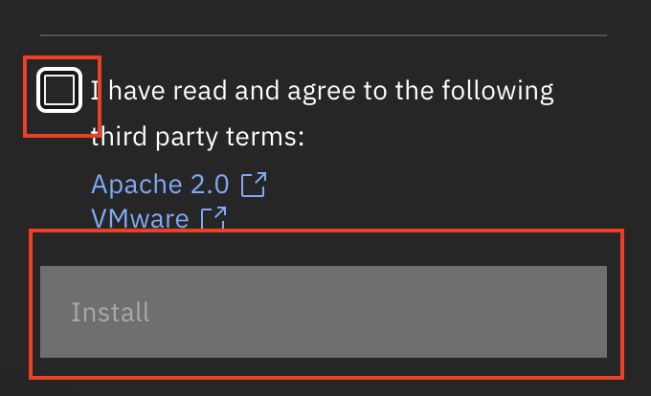

* The OwnCloud workspace will start installing, wait a couple of minutes

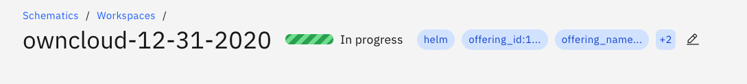

* Your OwnCloud workspace has been successfully deployed

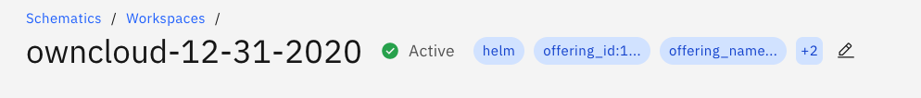

# Verify OwnCloud installation

* Go to [Resources](http://cloud.ibm.com/resources) in your browser
* Click on **Clusters**
* Click on your Cluster

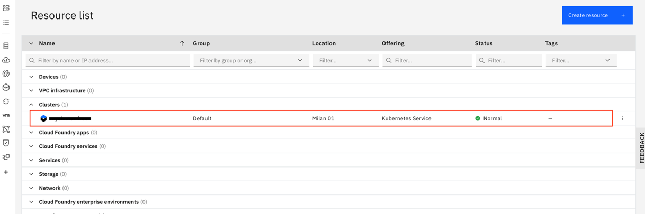

* Now you are at you clusters overview, here Click on **Actions** and **Web terminal** from the dropdown menu

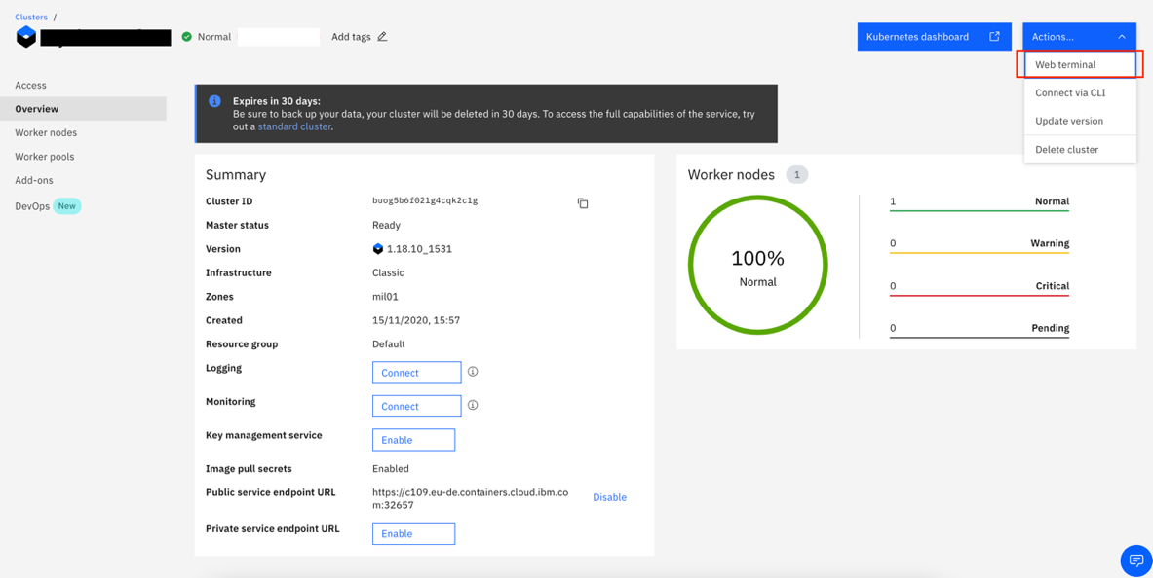

* Click **install** - wait couple of minutes

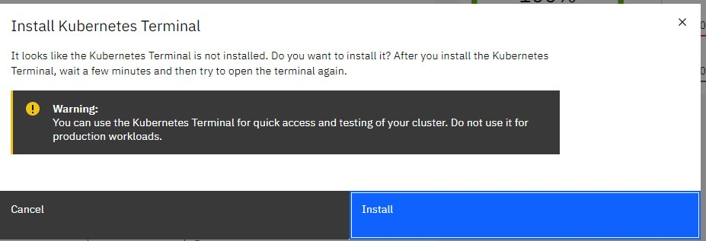

* Click on Actions
* Click Web terminal --> a terminal will open up
* Type in the terminal, please change NAMESPACE to the namespace you choose at the deployment setup:

$ kubectl get ns

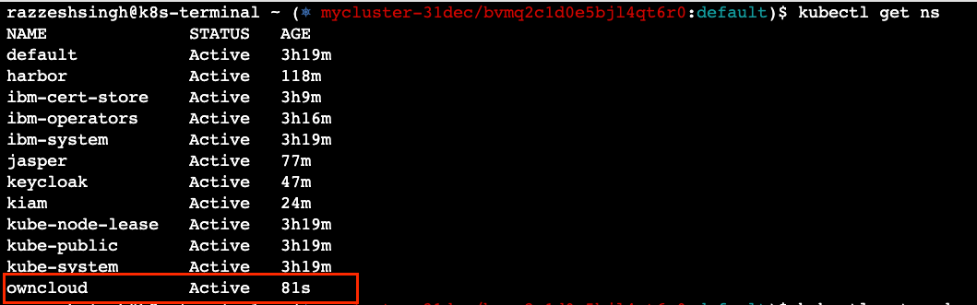

$ kubectl get pod -n NAMESPACE -o wide



$ kubectl get service -n NAMESPACE



* Open the OwnCloud application web page in browser using hostname or FQDN shown in above command.

